# Practice assessment

Case Scenerio: Library Donations

In this case donations are made by donors and this donation is used to purchase the book from sellers and each book will be different and specific genre. In purchase table we will take care about the each book by from donations.

Database model:

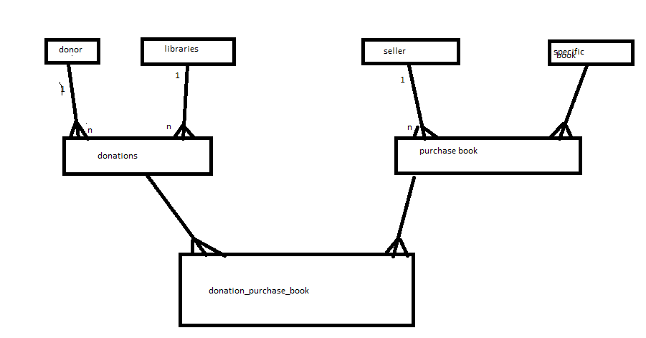

Now we can have multiple attribute for these entities   
Donor:

D_id,Dname,Dmoi,Damount

Libraries:

L_id,Lname,L_Location

Seller:

S_id,Sname,Smobi

Book:

B_id,B_name,B_author and so on

Now we will convert this database model to dimention model

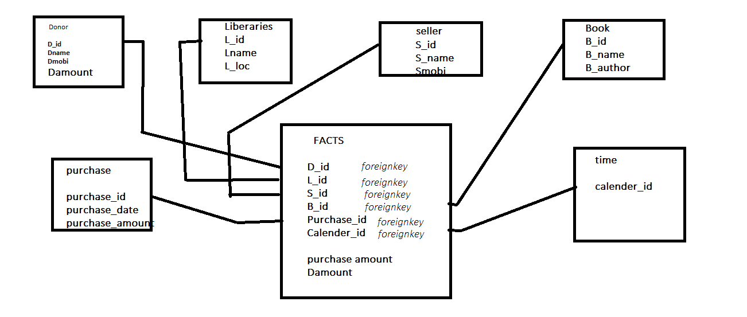

Now we can say here , we have 1 fact table and 6 dimentions

And we have relationship that

Donor to fact =1 to many

Liberary to fact=1 to many

Seller to fact=1 to many, book to fact=1 to many, purchase to fact =1 to many

Time to fact =1 to many

I am writing the fact table in mysql query

Create table facts(D_id int,L_id int(10),S_id int(10),B_id int(20),Calender_id int(10),purchase_Amount double,Damount double,foreign key(D_id)references donor(D_id),foreign key (L_id)references Liberaries(L_id),foreign key(S_id)references Seller(S_id),foreign key (B_id) references Book(B_id),foreign key (purchase_id) references purchase(purchase_id),foreign key(calender_id)references time(calender_id));

So further detail we can get it by fact table and dimentions also after the inserting the values.